**Networks Assignment 6**

**FTAP**

**README File**

G.V.S. CHETAN TEJA

B190436CS

**Introduction**

This is a file transfer application between single client and server used for transferring files (video, audio, text, jpg etc).

This application works using commands for communication with the server.

To login we must use the credentials which are stored in the server’s database.

For registration contact the admin.

**Commands**

**Command format:**

1) USERN <username>

2) PASSWD <password>

3) CreateFile <filename.txt

4) ListDir <no-parameters>

5) StoreFile <filename>

6) GetFile <filename>

1. USERN should be used before entering the username

Which on entering correctly returns the code **300**

**300 Correct Username; Need password**

Returns code **301** if entered incorrectly

**301 Incorrect Username**

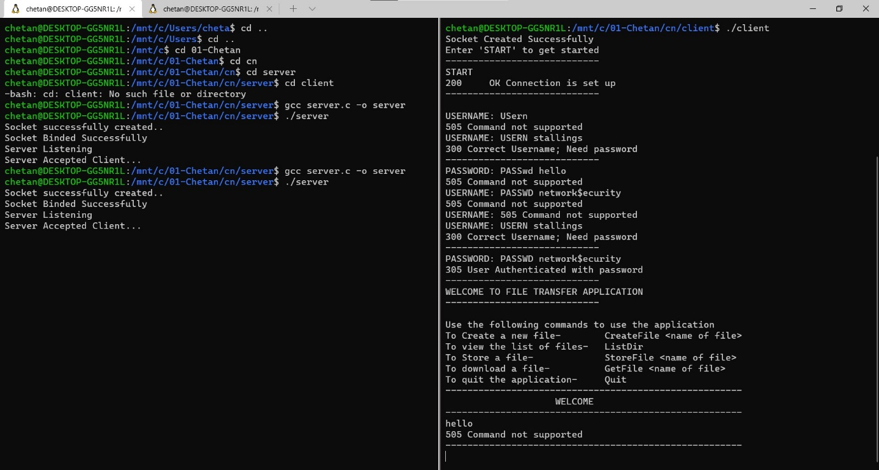

1. PASSWD should then be used before entering password

**305 User Authenticated with password**

Returns code **310** if entered incorrectly

**310 Incorrect password**

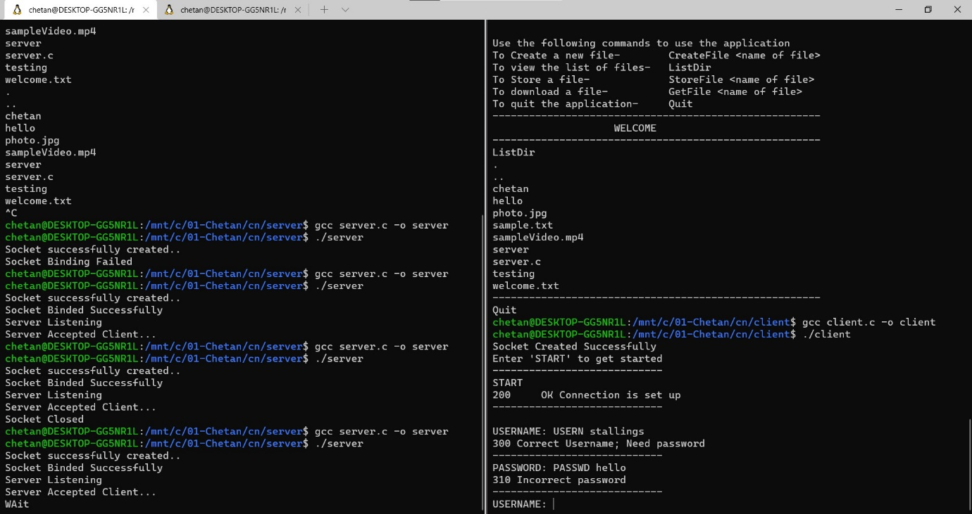

1. CreateFile command must be used to create a new file in the directory

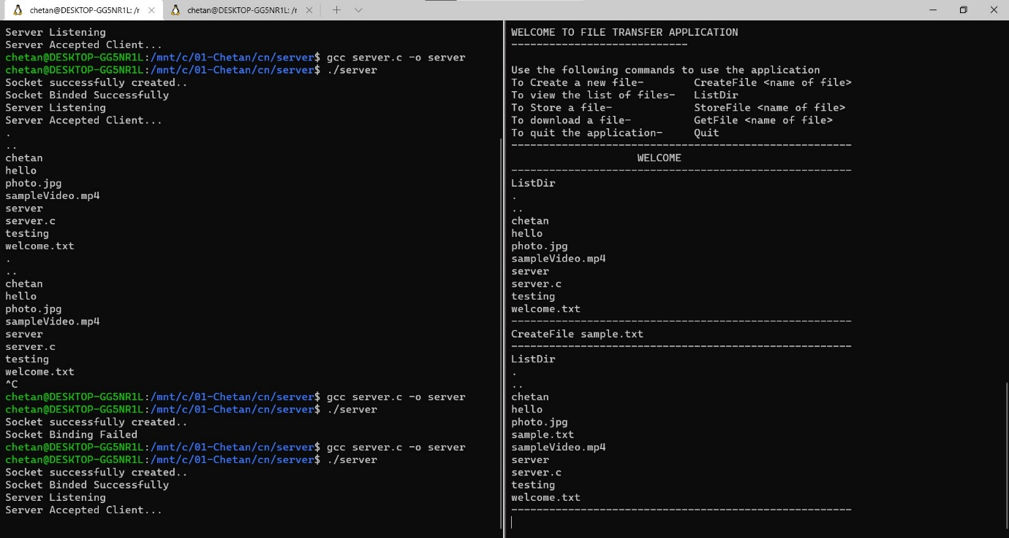

1. ListDir command to view all the files you have stored in the directory

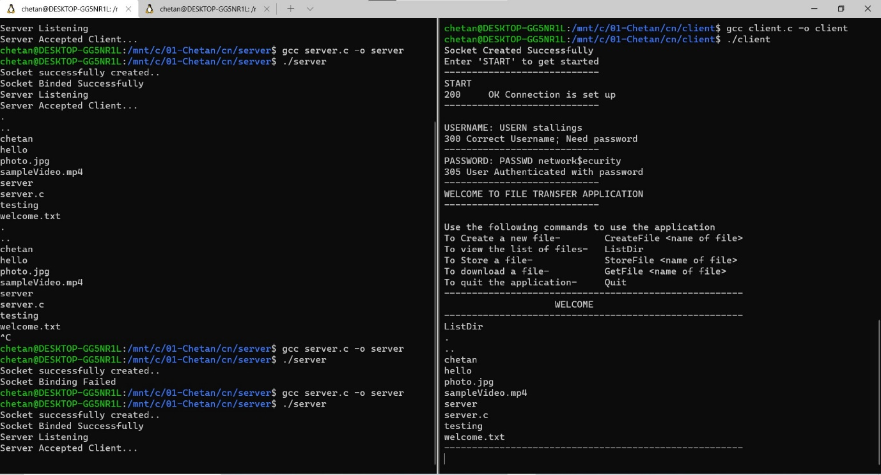

1. StoreFile command to store a file in directory (client shall upload this file from his directory to the server)
2. GetFile command to download a file present in server into client’s directory

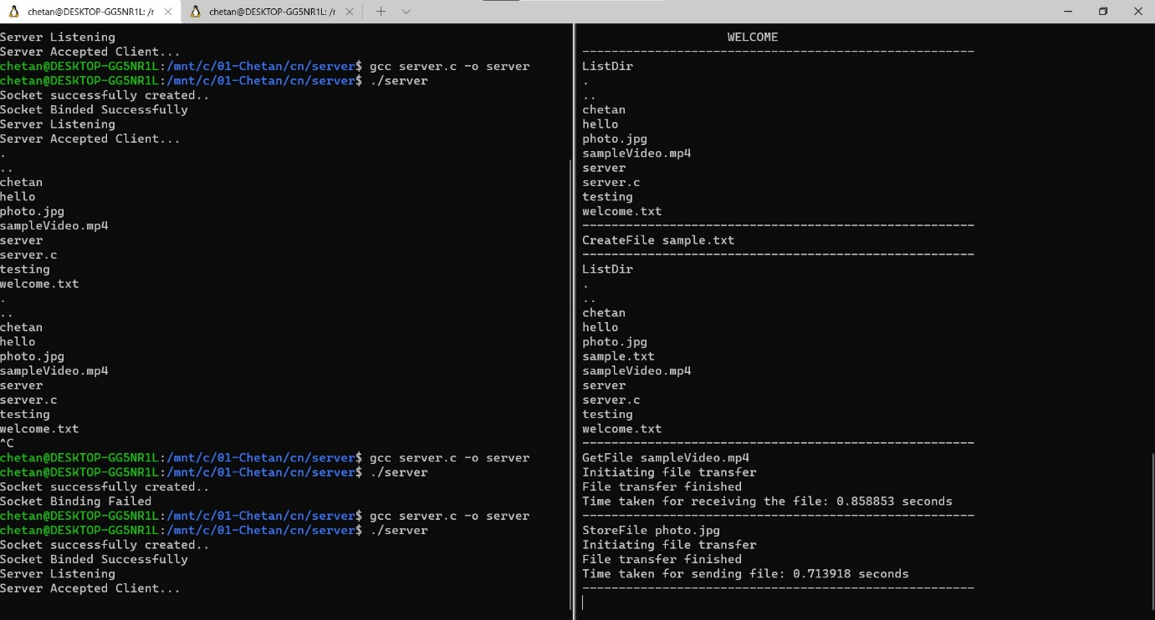

1. Quit command to exit the application

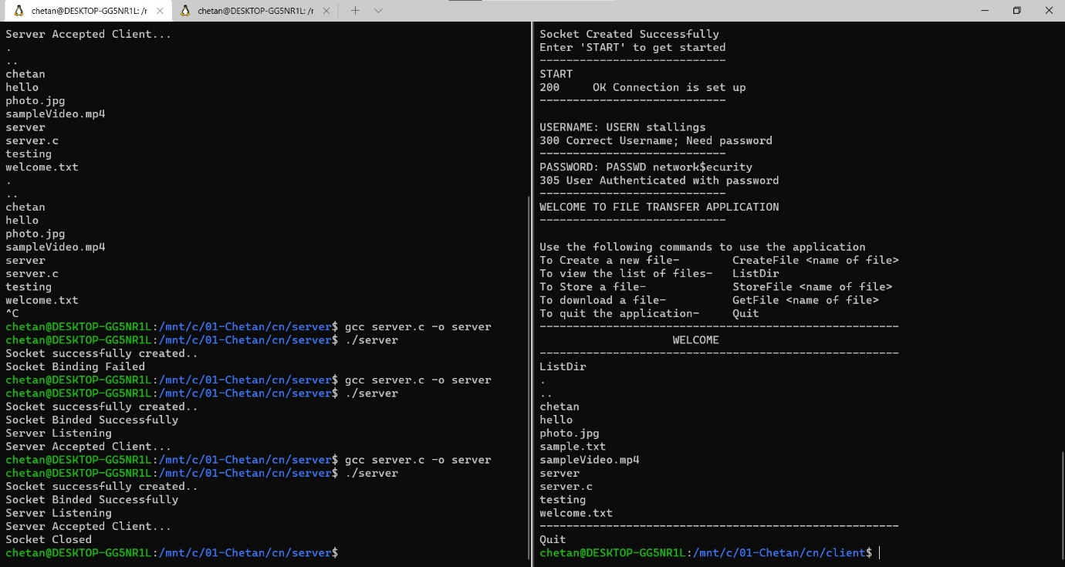

1. SERVER returns

**505 Command not supported**

For any command not applicable

This demonstrates the working of the application

THE END